Data Analysis using Cloud Technologies
Name – Shivam Tiwari
Student ID – 20210952
Email ID – shivam.tiwari3@mail.dcu.ie
Git Lab –
TASKS:
Task 1 : Get data from Stack Exchange (Data Acquisition/Collection)
Task 2: Load data into chosen Cloud Technology(MapReduce/Hive/Pig)
Task 3: Query data using MapReduce /Pig/Hive
Task 4: Calculate TF-IDF with MapReduce/ Hive/Pig
SOLUTIONS:
Assignment - 1
  - Data Acquisition
-Get the Data from Stack Exchange
-https://data.stackexchange.com/stackoverflow/query/new
-Data Exchange allows user to fetch only 50k data at one time , so we must fetch four .csv files and combine these files in order to get 200k data:
- To check maximum viewcount - select max(ViewCount) from posts
- Query select top 50000 * from posts where posts.ViewCount > 30000 AND posts.id NOT IN
(select top 150000 posts.id from posts order by posts.ViewCount DESC )order by posts.ViewCount DESC;

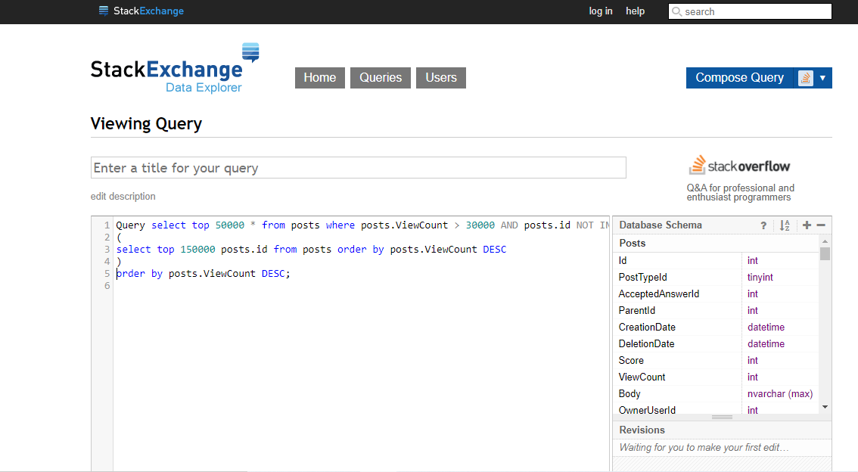

Screenshot of queries used in stack exchange to get the data from stack overflow,
Similarly, get the data four times to get the required 200k posts by ViewCount
Now combine the four downloaded .csv files Iam using copy command from command prompt
Screenshot of combine csv into one file as add.csv



Task 1.2 – Create an google Cloud platform instance-
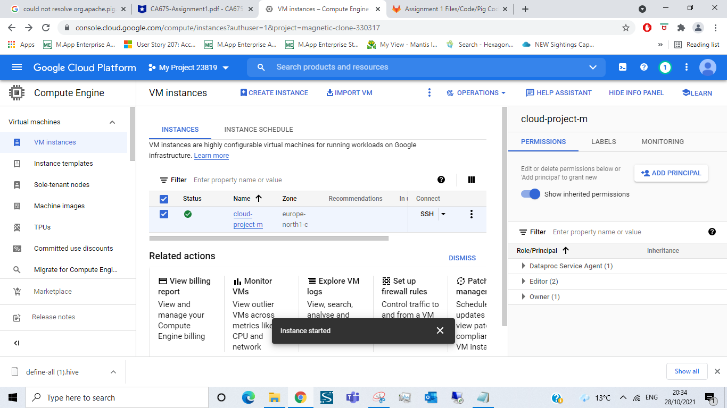Task 2: Load the data in GCP – the cluster was created and the cleaned csv file was uploaded in GCP
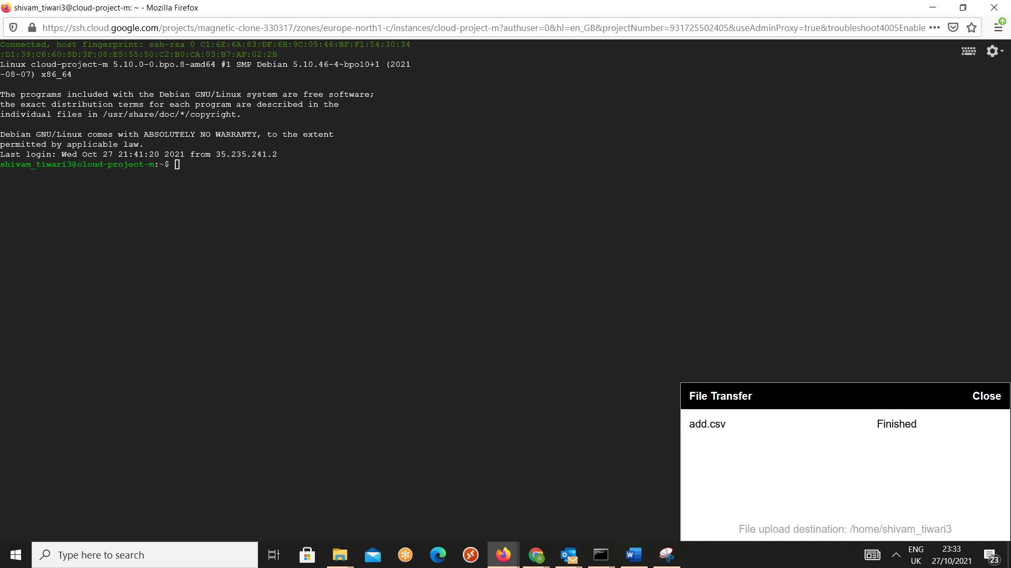

Task 3 – Create a database and a table using hive:
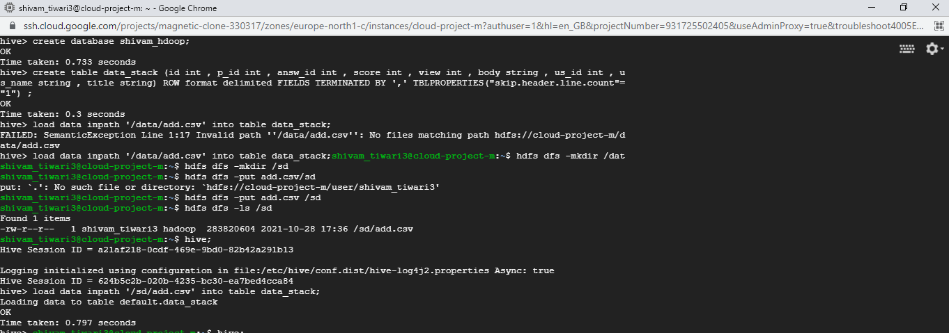
Task 3.1 - Top 10 posts by Score:
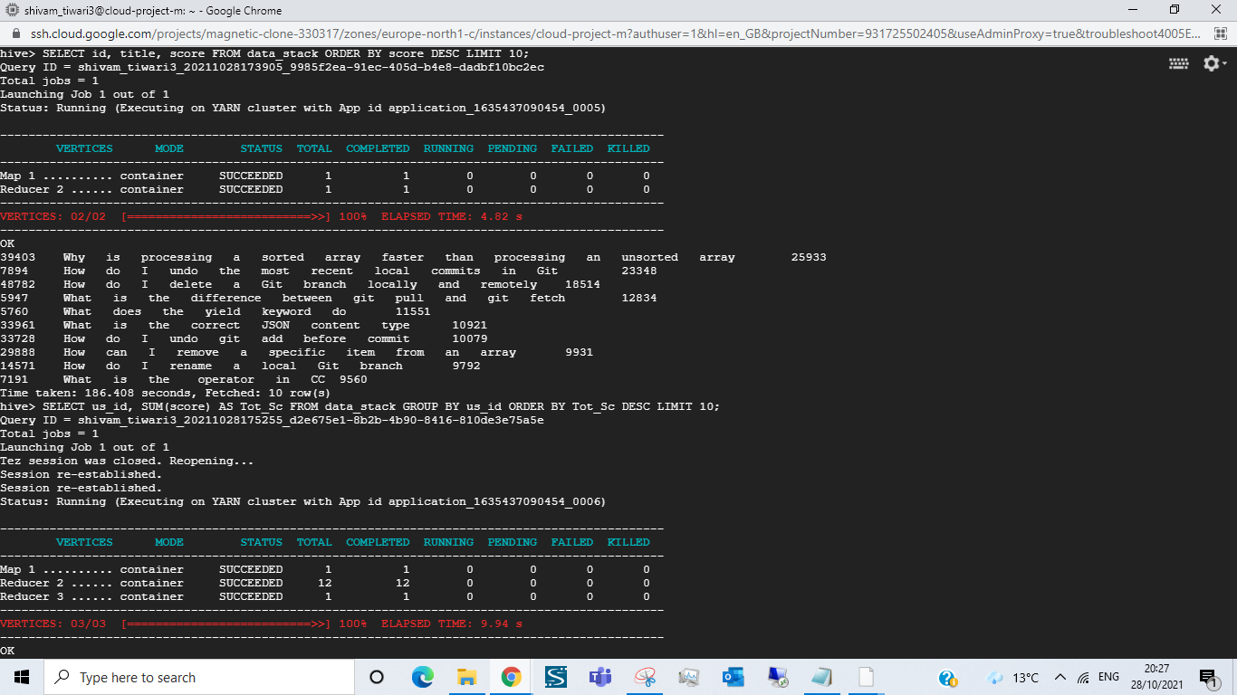
Task 3.2 – Number of users who used the word ‘cloud’ in their posts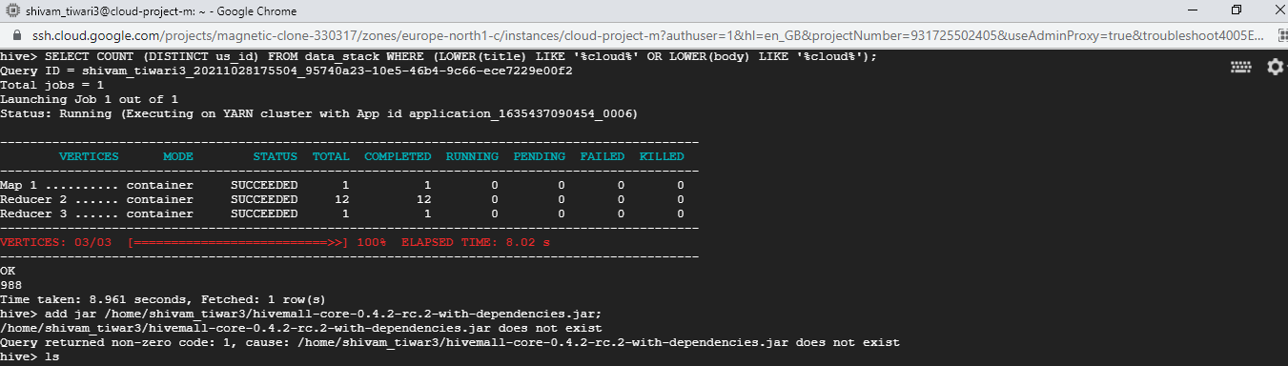

Task 4 – Calculate TF-IDF with hive:

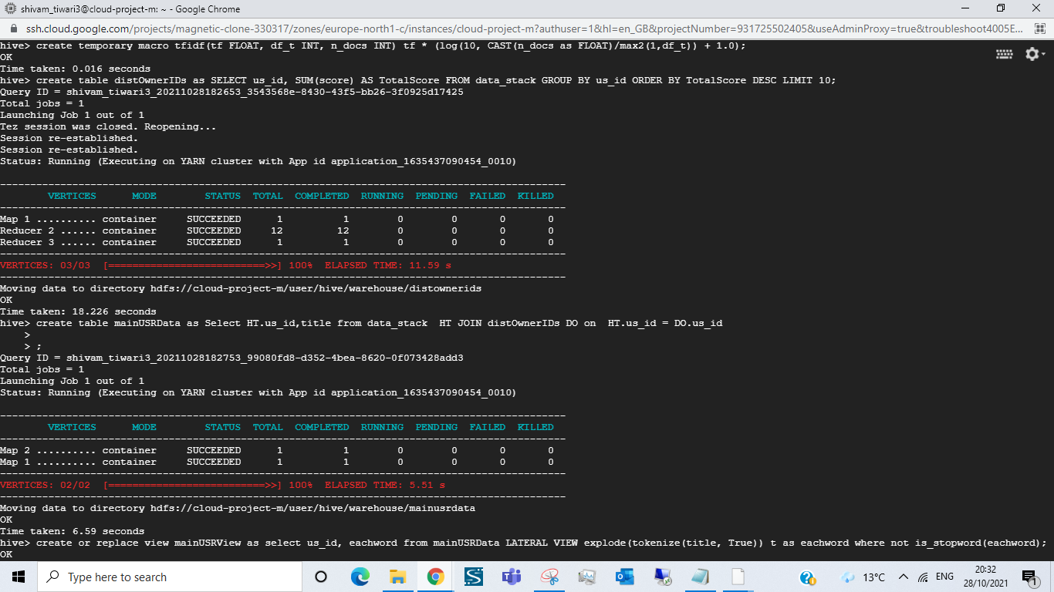

FINAL TF-IDF RESULTS:
